

|  |
| --- |
| **MATHEMATICS DEPARTMENT**  **Year 11 Specialist – 2016**  **Test Number 4:**  **Combinations and Circle Geometry**  **Resource Rich** |

**Name: _______________________________________ Teacher: DDA**

**Marks: 47**

**Time Allowed: 45 minutes**

**Weight: 7%**

**Instructions:** You are permitted 1 A4 page of notes and your calculators. Show your working where appropriate remembering you must show working for questions worth more than 2 marks.

_________________________________________________________________________

Part A

5 multiple choice questions

5 marks

**1**  Counting the 1 at the top as row 0, what is the fifth number on row 9 of Pascal’s triangle?

**A**  126

**B**    70

**C**   56

**D**  120

**E**  210

[1 mark]

**2**  In the diagram, O is the centre of the circle. The value of ∠ACB is:

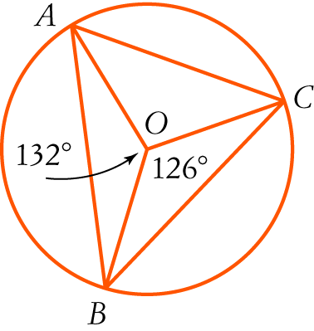

**A**  24°

**B**   27°

**C**  66°

**D**  63°

**E**  39°

[1 mark]

**3** The size of ∠VTU in the diagram is:

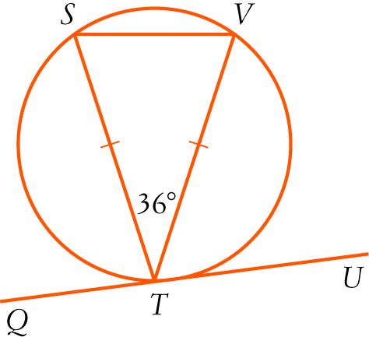

**A**   72°

**B**     54°

**C**    36°

**D**  18°

**E**    90°

[1 mark]

**4**  The value of x in the diagram is:

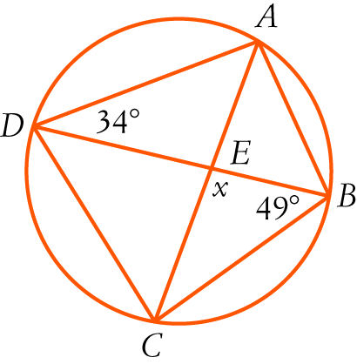

**A**  83°

**B**  68°

**C**  98°

**D**  96°

**E**    97°

[1 mark]

**5** 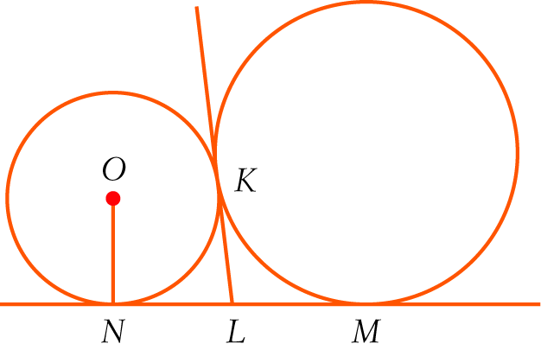

In the diagram, NM is a common tangent to the circles. KL is also a common tangent and O is the centre of the smaller circle.

Consider the statements:

I LN = NO II KL = LN III LN = LM

Which of the statements are true?

**A**  I and II

**B**  I, II and III

**C** II and III

**D**  I and III

**E**  None of the above.

[1 mark]

Part B

8 short answer questions

32 marks

Show your working where appropriate.

**6**  nC6 = 7 × nC4. Solve for n.

[5 mark]

**7**  There is only one black jelly bean in a packet with 20 left in it.

**a**  How many different selections of 6 jelly beans are possible?

**b**  How many selections include the black one?

[4 marks]

**8**  A class has 24 students. Of these students, 9 do not do any of Physics, Chemistry or Computer Science. There are 6 who do Physics and Chemistry, 4 who do Physics and Computer Science and 5 who do Chemistry and Computer Science. There are 11 Computer Science students, 8 who do Physics and 8 who do Chemistry. Use the inclusion-exclusion principle to find how many do all three of Physics, Chemistry and Computer Science?

[5 marks]

**9** What is the probability of getting exactly 2 faulty switches if you take 5 switches from a box of   
12 switches with 4 faulty ones in it?

[3 marks]

**10** In the diagram, DF = 6 cm and OE = 4 cm.

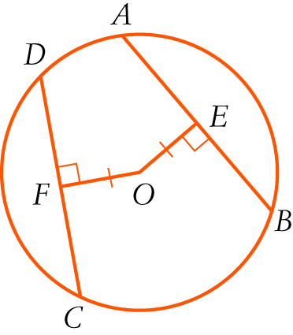

**a**  Find the length of AB giving reasons.

**b**  Find the radius of the circle in exact form.

[5 marks]

**11** Find the value of x in surd form, giving reasons.

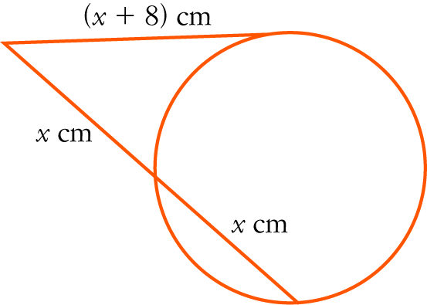

[4 marks]

**12** In the diagram, AB is a diameter of the larger circle with centre C and A is the centre of the smaller circle.   
The circles intersect at D. Explain why BD is a tangent to the smaller circle.

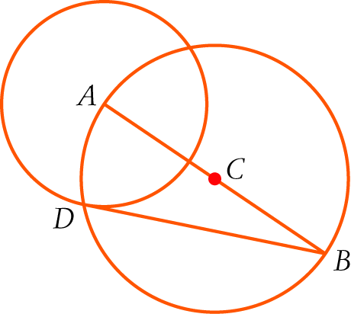

[3 marks]

**13** Find the value of x, giving reasons.

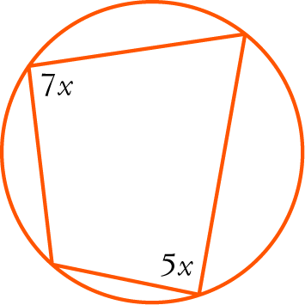

[3 marks]

Part C

2 analysis questions, 10 marks. Show your working where appropriate.

**14** The ninth number of a row of Pascal’s triangle is half of the eighth number in the row. What is next (tenth) number in the row?

[5 marks]

**15** In the diagram, TR = TS. Prove that PQ = PR.

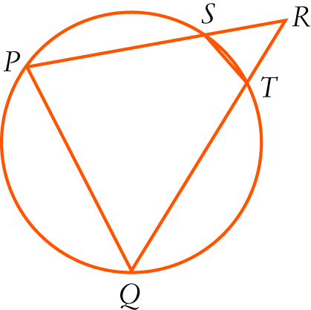

[5 marks]